Course
Registration
System

User

Manual

Table of Contents

Table of Contents 2
Introduction 3
Getting Started 3
Role Overview 3
Student Menu 4
Class Registration 4
Drop A Course 5
Add A Course 5
View My Grades 6
Browse Course Catalog 7
Instructor Menu 8
View Section Registration 8
Assign Grades 9
Department Head Menu 12
Course Information 13
Course Prerequisites 13
Administrative Menu 14

Introduction
Welcome version 1.0 of the Course Registration System! This portal application provides students, instructors, and administrators with a single integrated course management solution. With this tool, students can browse the course catalog, register for courses, and view their grade history. Instructors can monitor section registration and assign grades to students. And certain administrative personnel can update the course catalog.

Getting Started
Each individual uses a unique 9-digit university identifier to log into the Course Registration System. In most cases this will be your federally-issued Social Security Number. Please obtain your default password for this system from the registrar’s office. It is strongly recommended you change your password the first time you log in so that others cannot access or make changes to your profile.

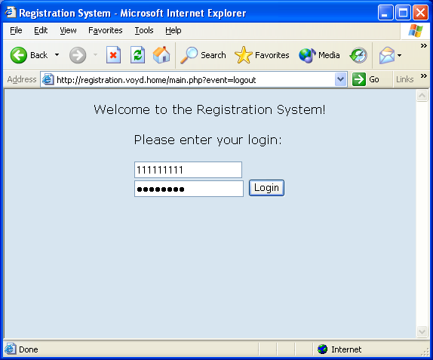

Role Overview
The Course Registration System identifies three types of roles for its users: students, instructors, and department heads. The roles you are assigned to will affect what your main menu looks like upon logging in and what functions you can access. There is a separate menu for each role plus an administrative menu that everyone can access. A user can have multiple roles, for example if a user is teaching one course, but enrolled in another. In that event, both the Student and Instructor menus will be visible on login.

Student Menu
The student menu has three functions: Class Registration, View My Grades, and Browse Course Catalog.

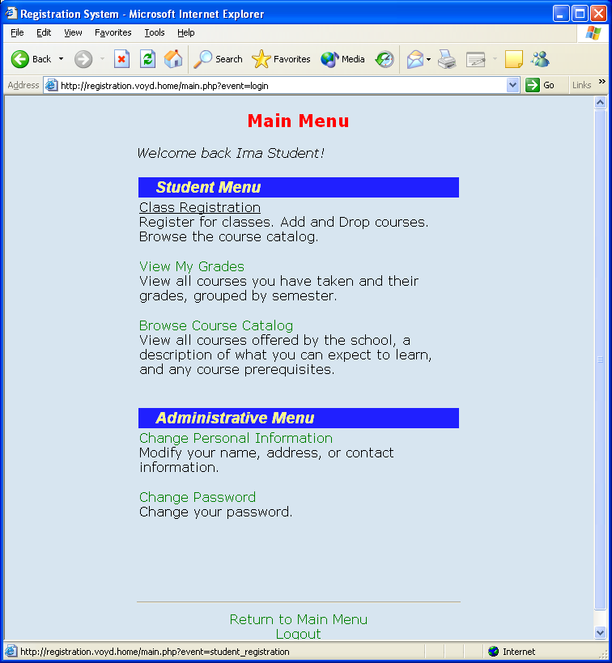

The Class Registration function option allows you drop and add courses for the current registration semester. The View My Grades function allows you to access your course grades for all semesters prior to the current one. The Browse Course Catalog allows you to view all courses in the system by department.

Class Registration
This page lists all your currently registered courses for the current registration semester, its corresponding teacher, class locations, and class times.

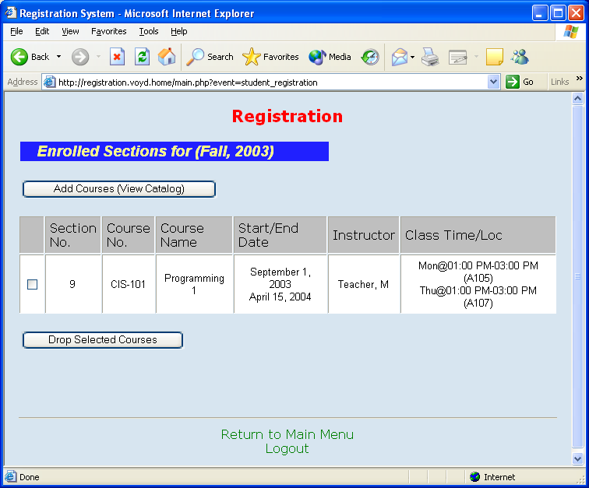

Drop A Course
To drop a course, select the checkbox next to the course(s) you want to drop and press the “Drop Selected Courses” button. This will remove them from your course list. You are only allowed to drop within 10 weeks of the start of the semester. After that time, a next semester’s courses will appear on this registration page.

Add A Course
To add a course, click on the “Add Courses” button. This will take you to the Course Catalog. Select the department you are looking to add a course, find the course in the list, find the section that best matches your schedule, and press “Add”. (The system unfortunately will not check your schedule… it’s up to YOU to manage that!)

If a section has reached the max number of allowed students, you will not see an “Add” button next to the section. Instead the word “Closed” will appear.

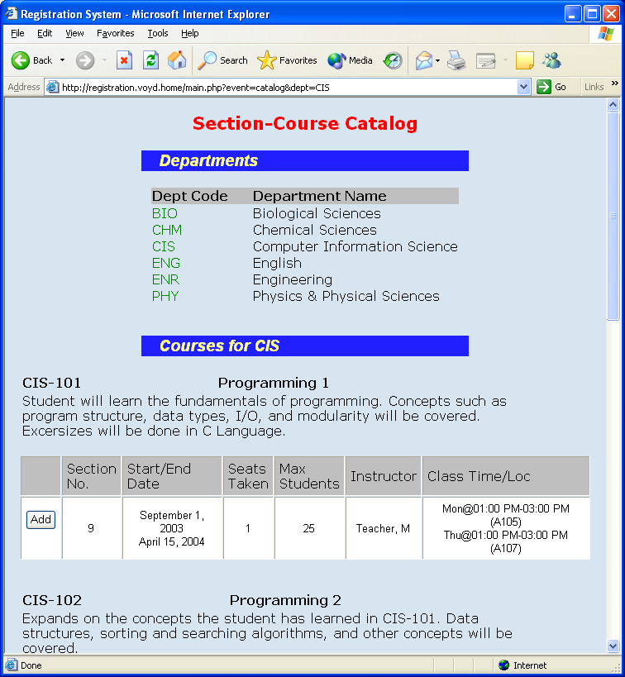

View My Grades
The View My Grades function allows you to view your grades for all semesters prior to the current one. A semester becomes available on this page after the last day of classes.

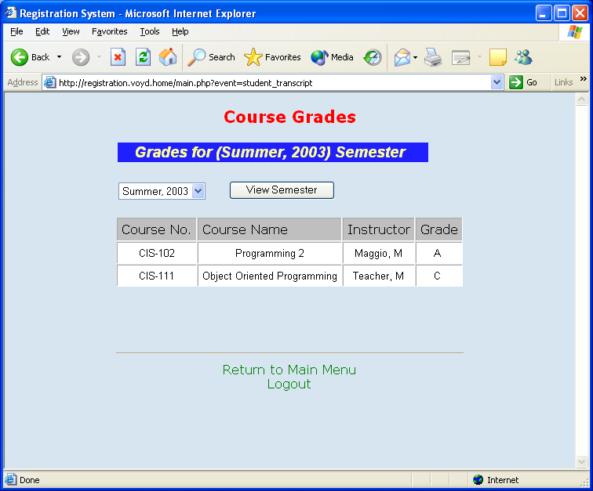
To select a different semester to view you grades, select that semester from the drop-down box. Only semesters for which you have registered will appear in this drop-down. If you have not registered for any courses prior to this semester, you will receive an error.

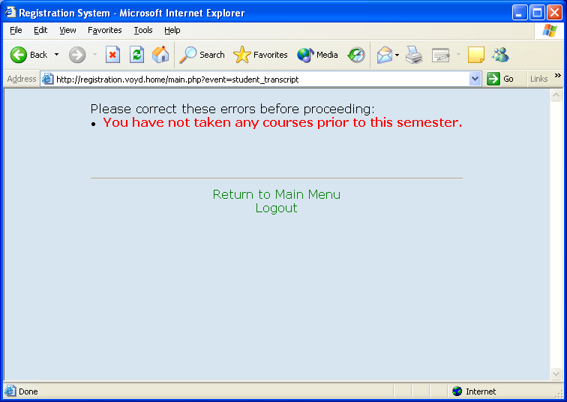

Browse Course Catalog
The Browse Course Catalog option allows you to view all courses in the system, regardless of whether or not there are any sections offered this semester. As you can see in the picture below, there is no section information in this view:

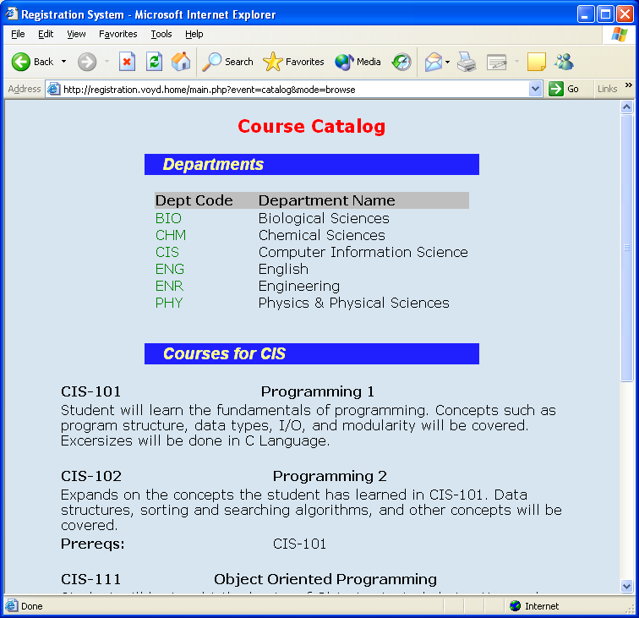

Instructor Menu
The instructor menu has three functions: View Section Registration and Assign Grades.

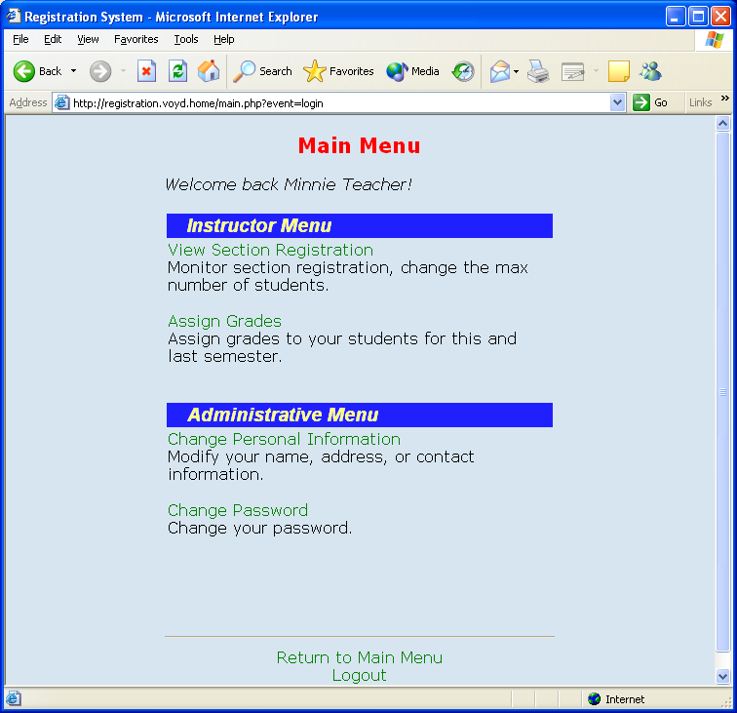

View Section Registration allows you to monitor the registration of the sections you are taking this semester and modify the maximum number of students allowed in the section. Assign grades allows the instructor to Assign Grades to students during the current and last semester.

View Section Registration
The View Section registration function presents you with a list of all sections you are slated to teach this semester, the time/location of the class, and the number of students entering the class.

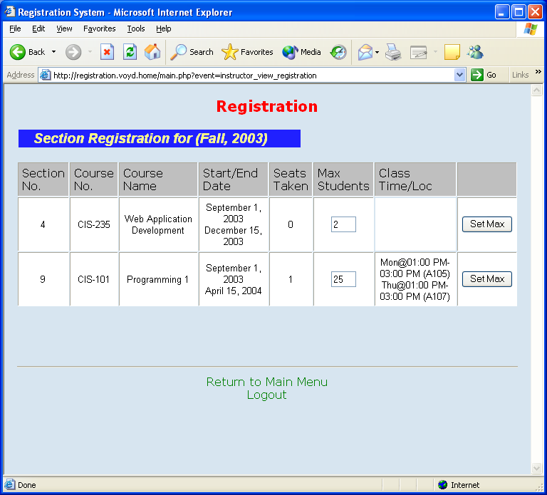

You can change the max number of students for a class by changing the value and pressing the corresponding “Set Max” button for that section row. The course maximum cannot exceed the lowest maximum capacity of all classrooms you will be teaching in. For example, if you meet in classroom A on Mondays and classroom B on Tuesdays, classroom A has max of 25 and classroom B a max of 50, your maximum number of students for the section cannot exceed 25.

Assign Grades
The Assign Grades function allows you to set the grade of all students enrolled in your sections. If a grade has already assigned to a student, you are only allowed to increase it.

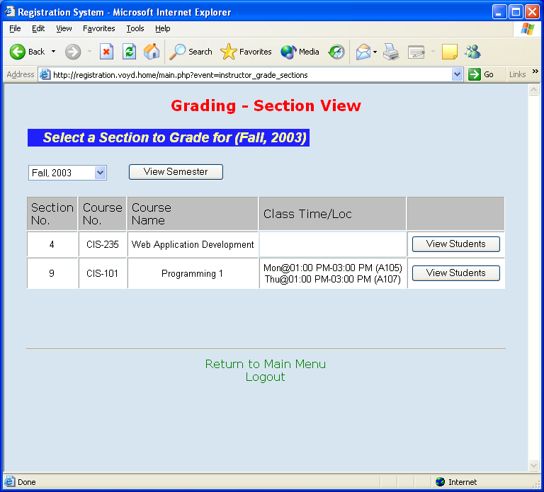

To change the semester you want to set grades for, select the semester from the drop-down and press “View Semester”. You can only view the current and previous semester.

To view all sections registered for the course, click “View Students” next to the corresponding section.

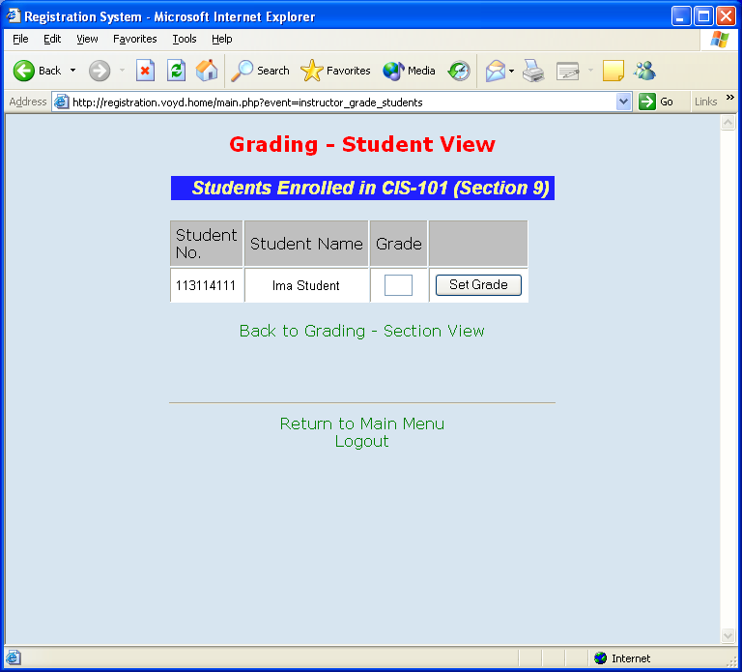

Next, to assign a grade to the student, place the letter in the Grade field and click “Set Grade” for that student. Only standard letter grades (A through D, and F) are accepted. Lowercase is also accepted for convenience and will be converted to uppercase.

Department Head Menu
The department head user will see a list of all departments he/she is capable of changing course information in their menu on login. The English catalog

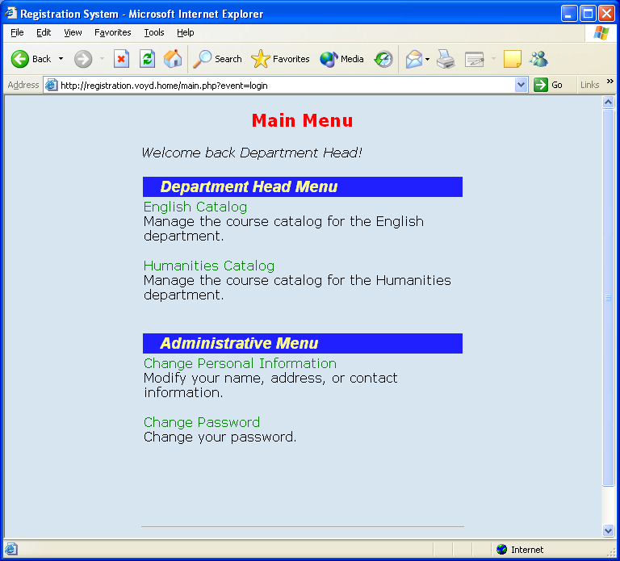

To modify courses for a department, select the department you wish to administer. You will receive an admin view of the course catalog for that department.

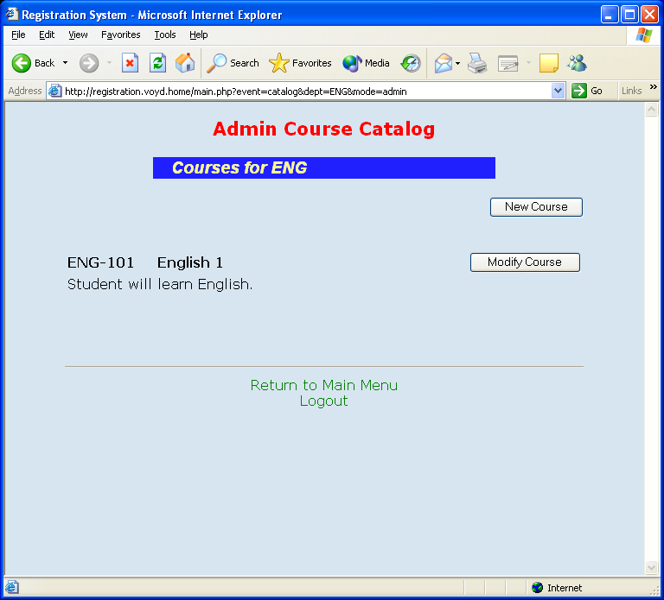

You are allowed to define a new course or modify an existing course. Selecting either will bring up the same form, but modify will prepopulate all fields on the form for that course.

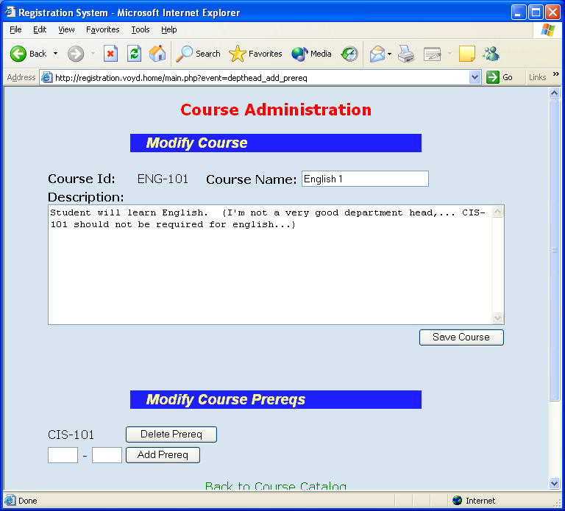

Course Information
You are allowed to modify the description and name of the course. Type the text in the appropriate fields and press “Save Changes” when complete. In addition, in “New Course” mode, you must also specify the Course Number – a field which is not available to change in Modify mode. The Department Id component of the Course Number cannot be changed in either mode.

Course Prerequisites
To add a prerequisite, enter the full Course Number of the prerequisite and press “Add Prereq”. The system will check that the prerequisite does not already exist and that the course does. You cannot make a course a prerequisite of itself.

To remove a prerequisite, press “Delete Prereq” next to the prerequisite course number.

Administrative Menu
The administrative menu is available for all roles. You are allowed to change your password and your personal information.

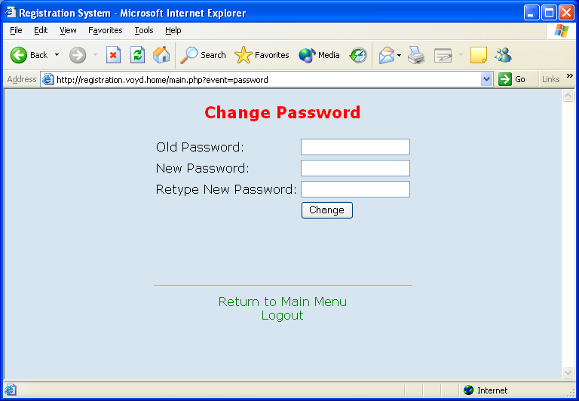

When changing your password, you must specify your existing password as a security precaution, and type in your new password twice to make sure you typed it correctly.

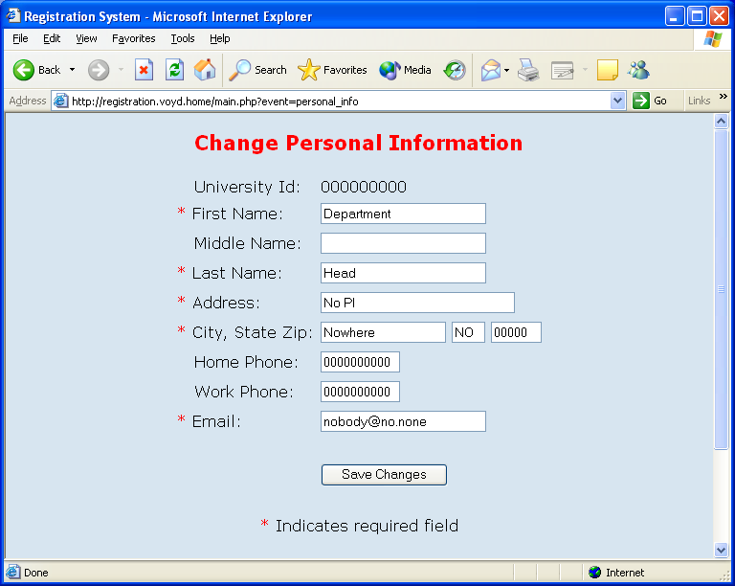

The system also keeps track of your personal address and contact information for university records. All fields marked with a red star are required fields.

