Course
Registration
System

Test Cases

Table of Contents

Table of Contents 2
Student Test Cases 3
Test Case #1 – Cannot Add Closed Course 3
Test Case #2 – Closing a Course 4
Test Case #3,#4 – Add Course w/ Prereqs 5
Test Case #5 – Drop Course edits. 6
Test Case #6 – Drop course. 7
Test Case #7 – Add Course w/o Having Prereqs 8
Test Case #8 – View Grades for a semester 9
Instructor 10
Test Case #1 – View Current Section Registration 10
Test Case #2 – Set Maximum above classroom Max 11
Test Case #3 – Set Maximum 12
Test Case #4 – View grading sections 13
Test Case #5 – View Enrolled students 14
Test Case #6 – Assign Grade 15
Test Case #6 – Decrease Grade 16
Test Case #7 – Increase Grade 17
Department Head 18
Test Case #1 - View Catalog As Dept Head 18
Test Case #2 – Add course 19
Test Case #3 – Add Prereq that does not exist 20
Test Case #4 – Add Course as Prereq to Itself 21
Test Case #5 – Add Prereq (no errors) 22
Test Case #6 – Add Prereq that Already Exists 23
Test Case #7 – Delete Prereq 24

Student Test Cases

Test Case #1 – Cannot Add Closed Course

In the event that a course has closed between the time the page is loaded and someone else registers for the course, the Add button is still present on the browser so we need to test if the course has not already closed.

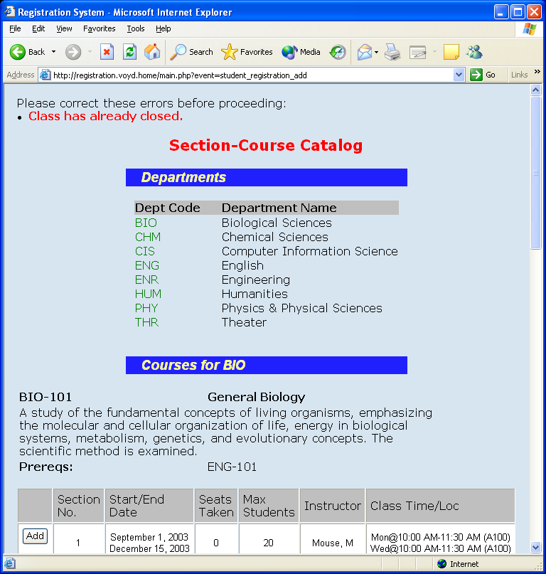

Test Case #2 – Closing a Course

Add button disappears if seats taken equals max students.

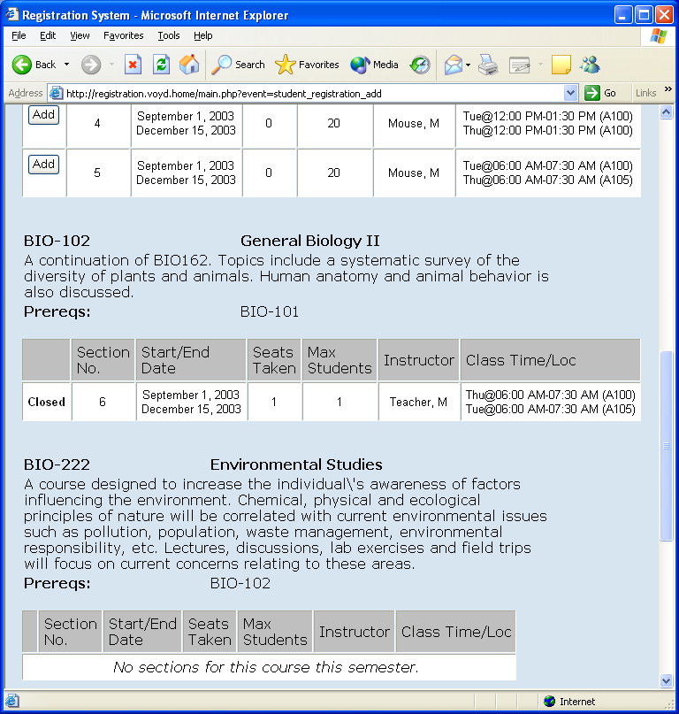

Test Case #3,#4 – Add Course w/ Prereqs
- Can retake course (in this case, one that has been taken already)
- Can add course having met all prereqs.

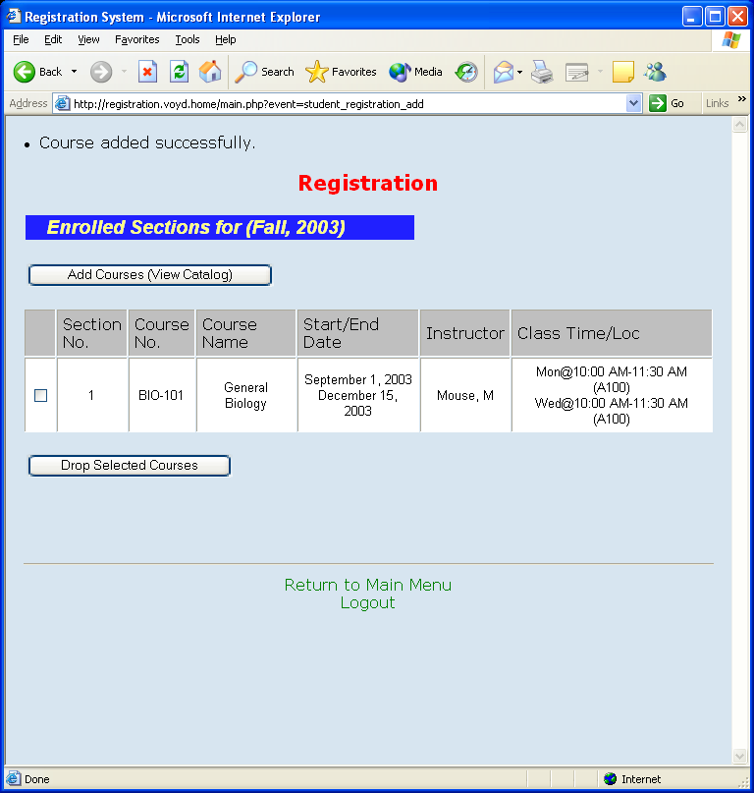

Test Case #5 – Drop Course edits.

Makes sure you checked boxes.

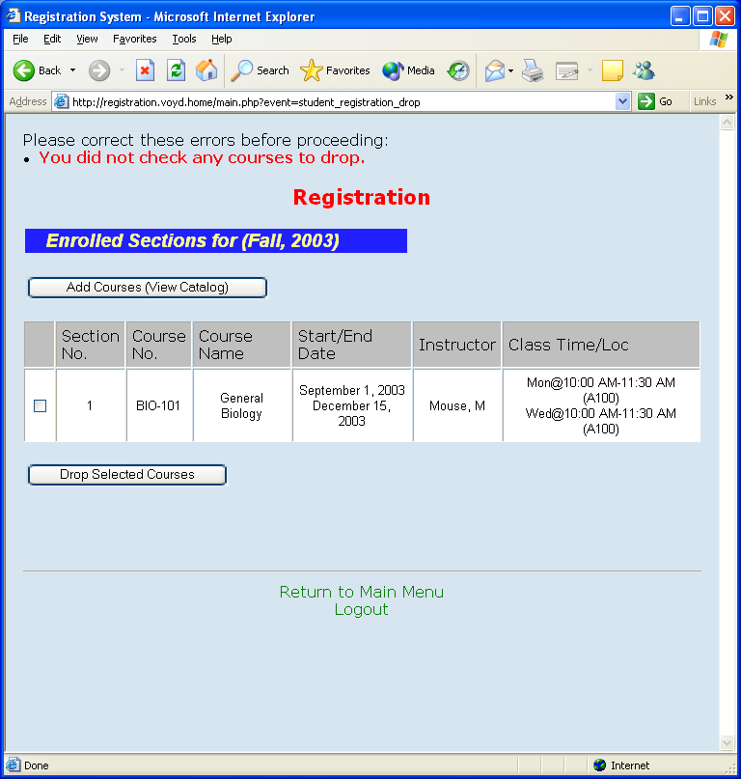

Test Case #6 – Drop course.

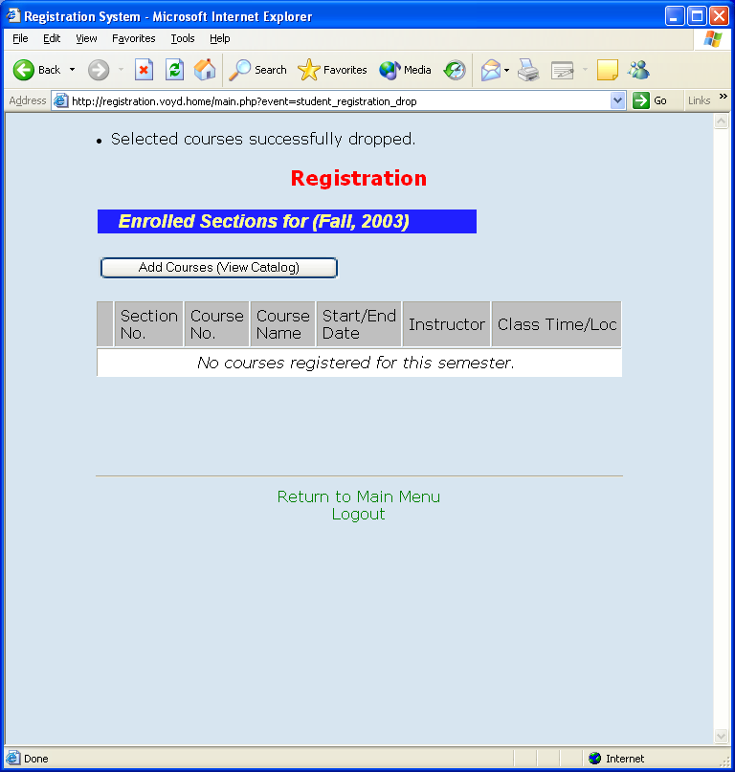

Test Case #7 – Add Course w/o Having Prereqs
– Cannot add course w/o having taken prerequisites.

(Attempted to add BIO-222)

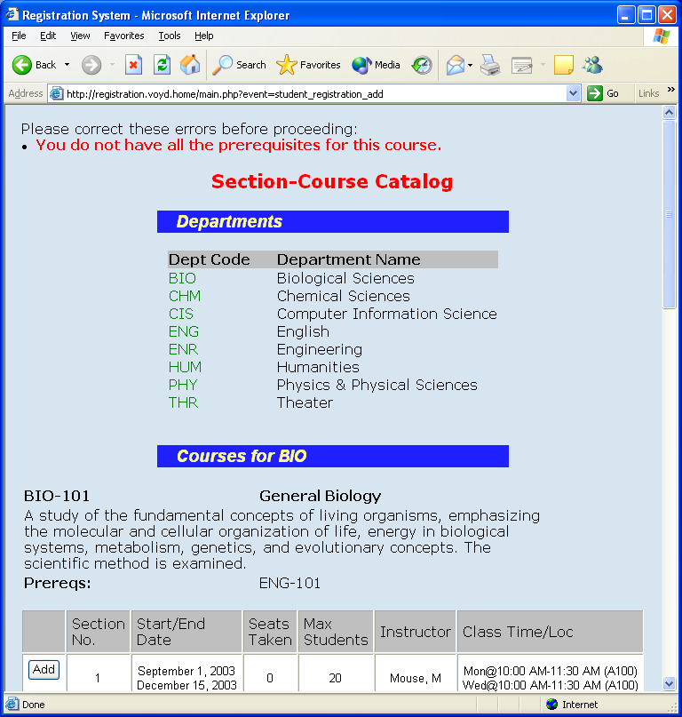

Test Case #8 – View Grades for a semester

Shows grades for past courses.

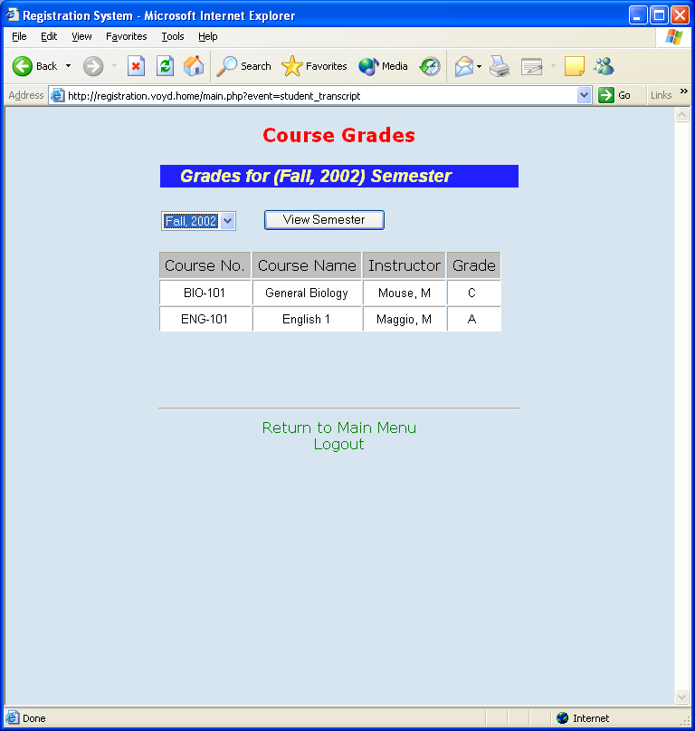

Instructor

Test Case #1 – View Current Section Registration

Shows all sections and current enrollment.

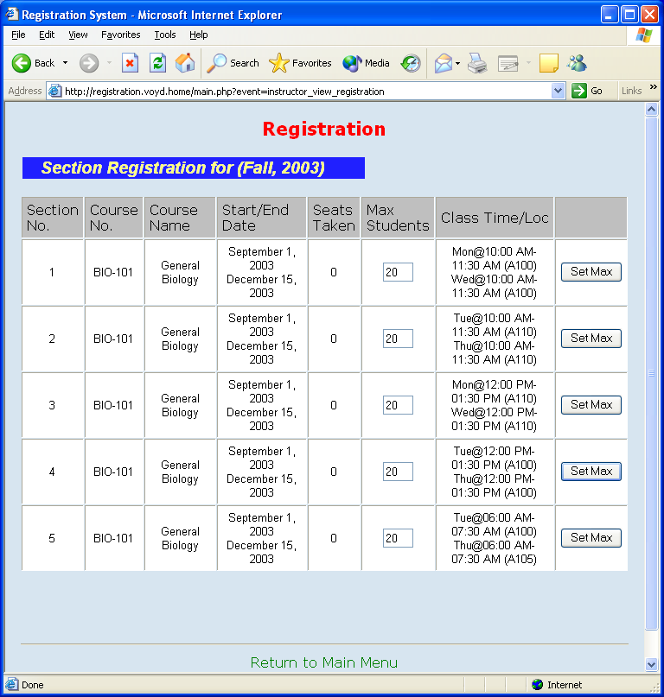

Test Case #2 – Set Maximum above classroom Max
Attempted to set to 100 on section 1. A100 is limited to 25 students.
(note: value of field resets to previous value)

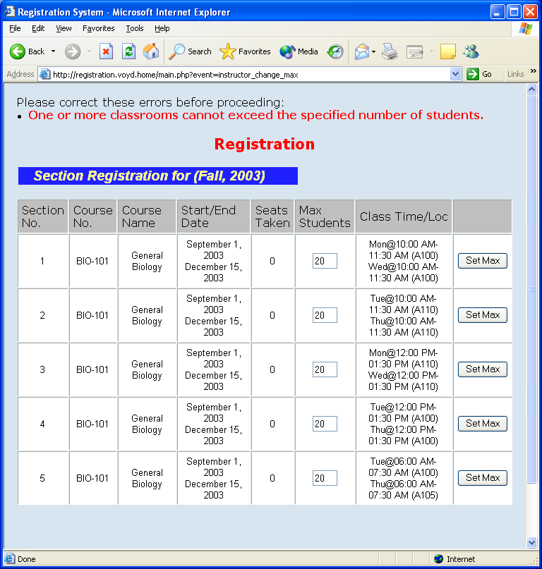

Test Case #3 – Set Maximum

Section 1 changed to 25 students.

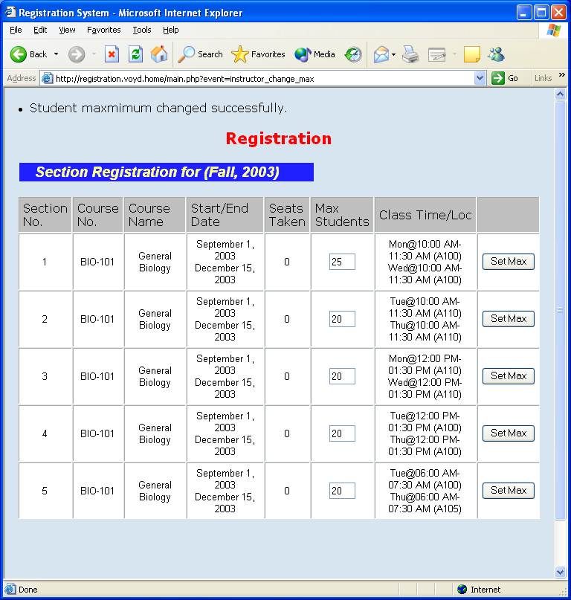

Test Case #4 – View grading sections

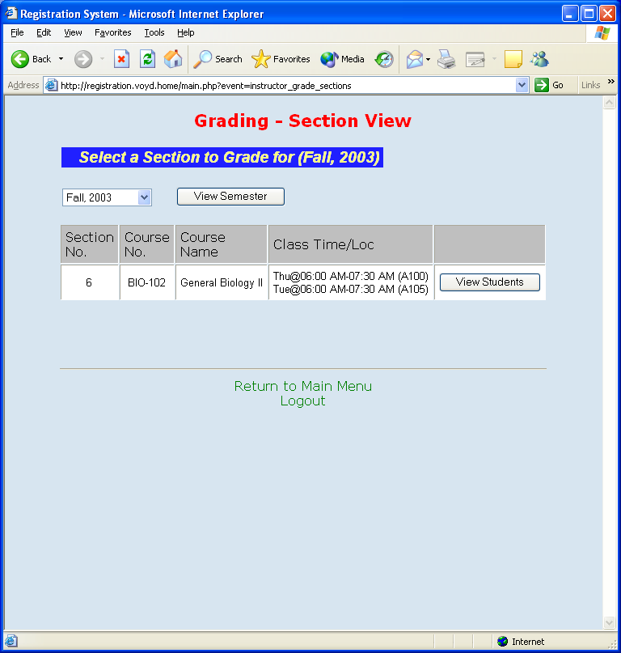

Test Case #5 – View Enrolled students

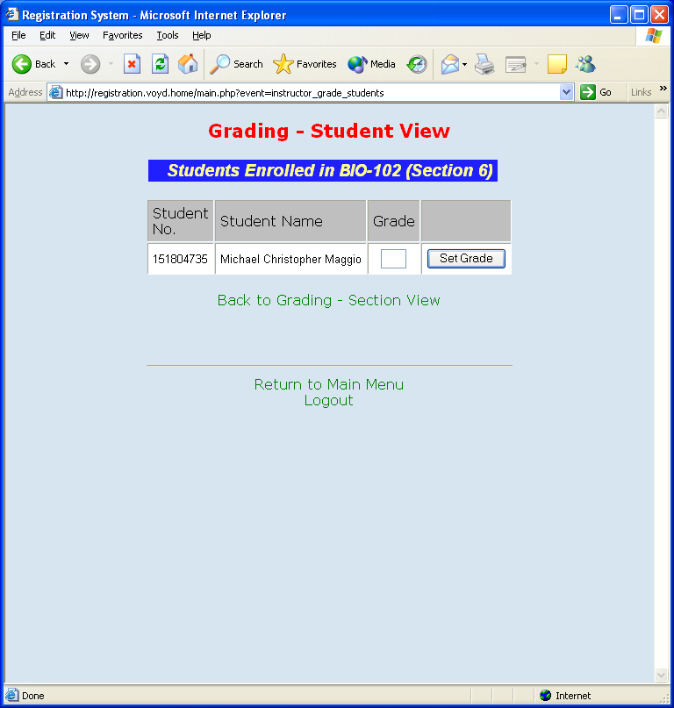

Test Case #6 – Assign Grade

Assign grade “C”.

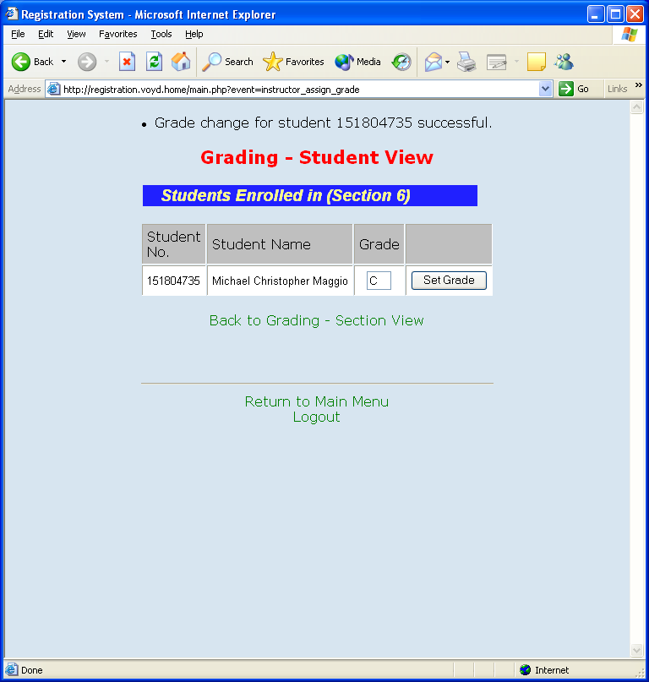

Test Case #6 – Decrease Grade

Attempt to decrease to D

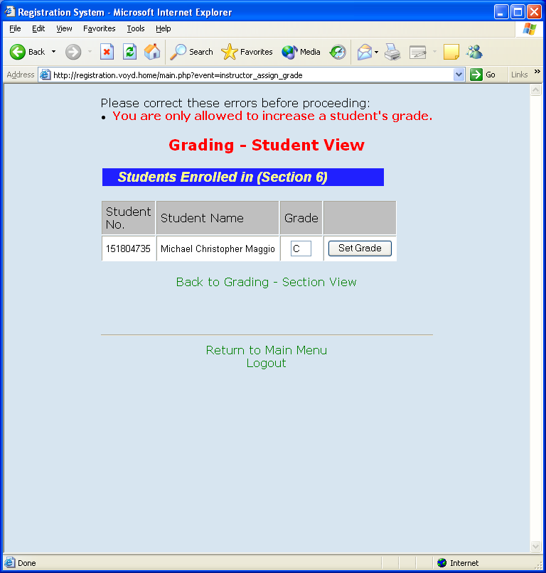

Test Case #7 – Increase Grade

Increase to “B”.

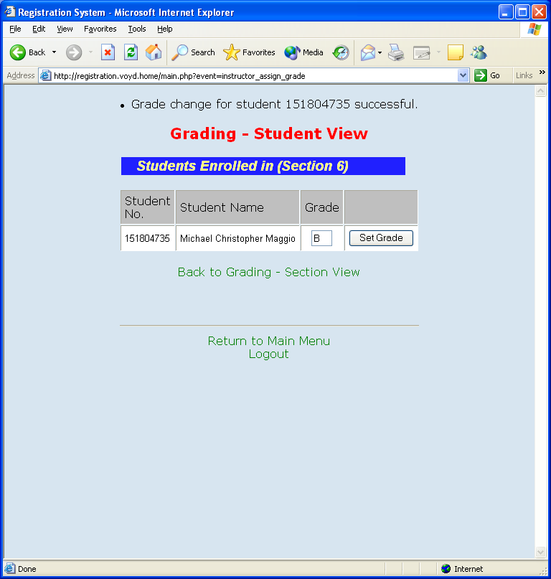

Department Head

Test Case #1 - View Catalog As Dept Head

Department head of Theater’s admin course catalog view. Note New Course and Modify Course buttons.

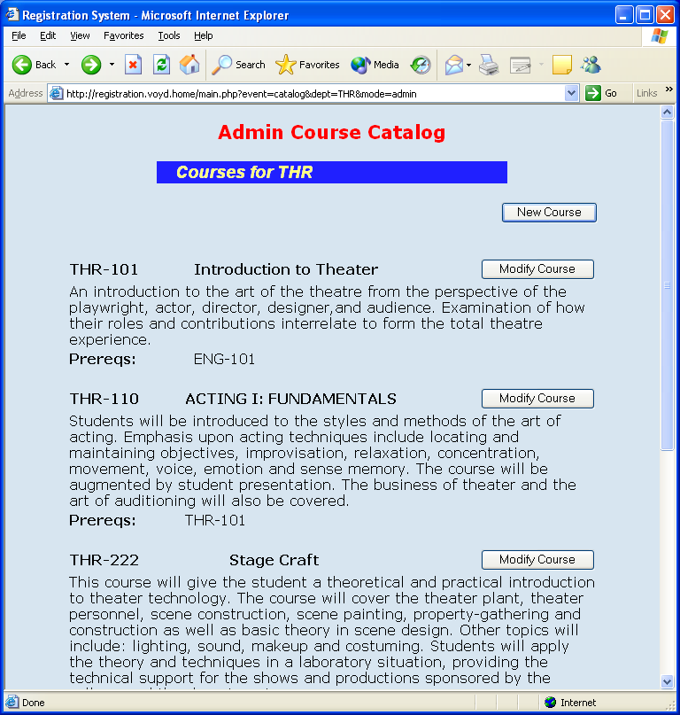

Test Case #2 – Load “Modify Course”

All fields are prepopulated.

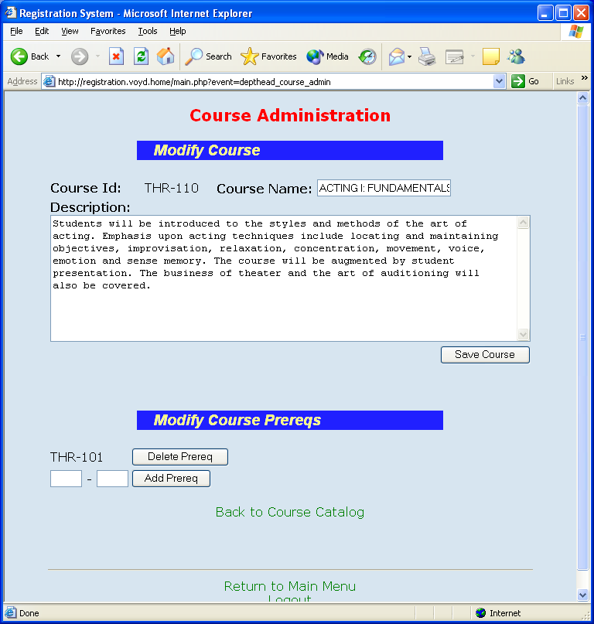

Test Case #3 – Load “New Course”

No fields are prepopulated and course id is editable.

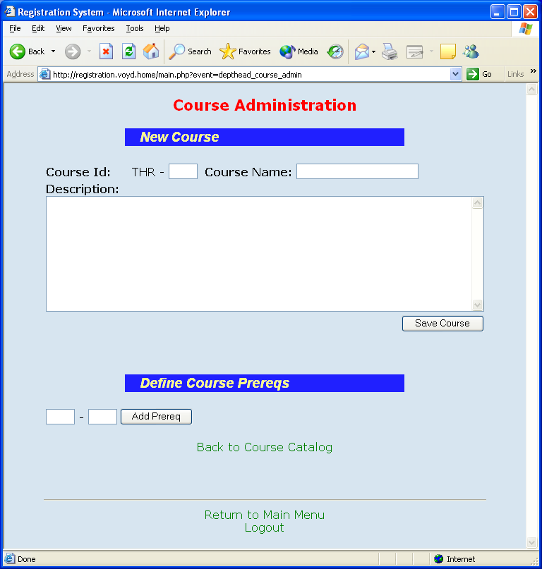

Test Case #4 – Add course

New course screen becomes modify course screen and course id is no longer editable.

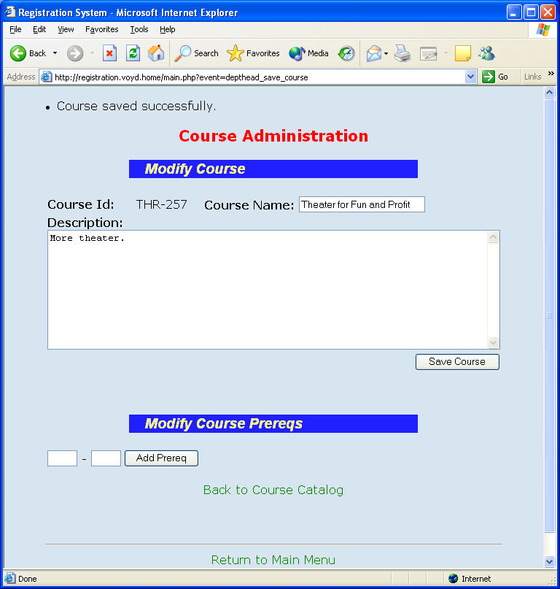

Test Case #3 – Add Prereq that does not exist

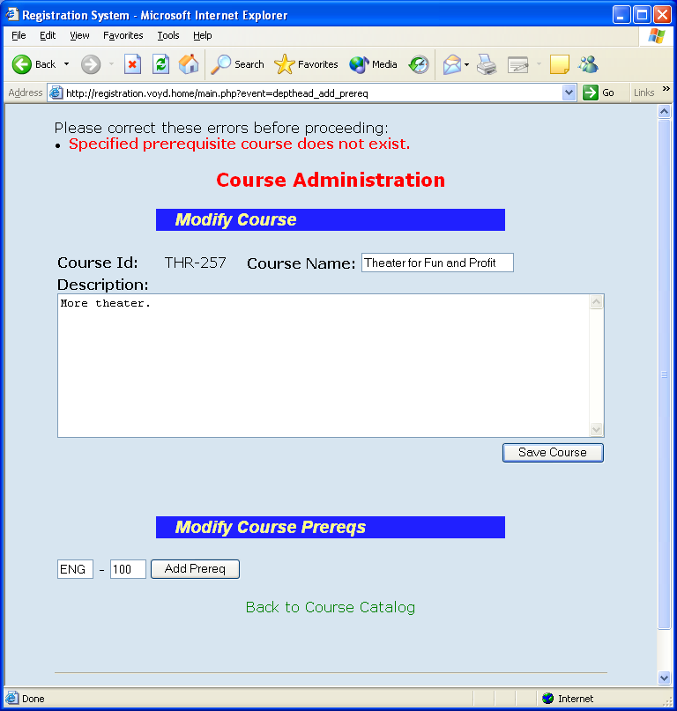

Test Case #4 – Add Course as Prereq to Itself

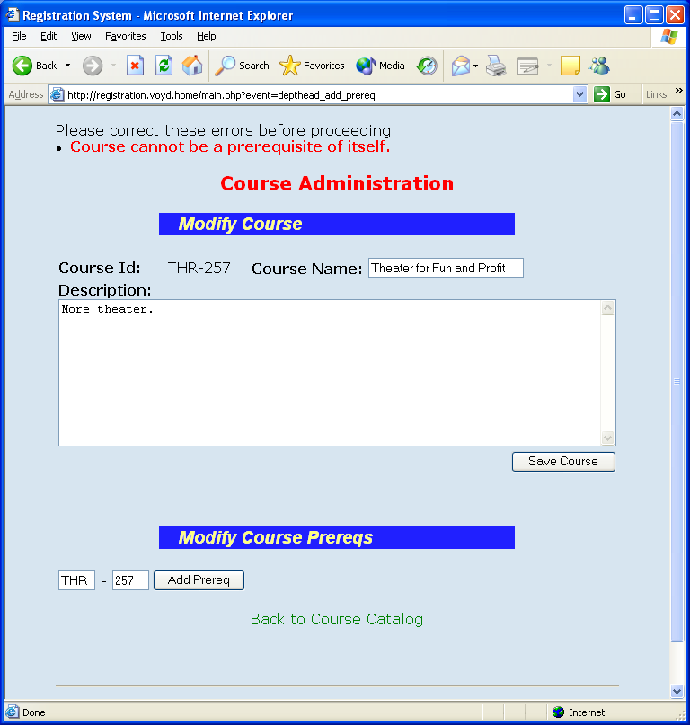

Test Case #5 – Add Prereq (no errors)

Added prereq THR-101.

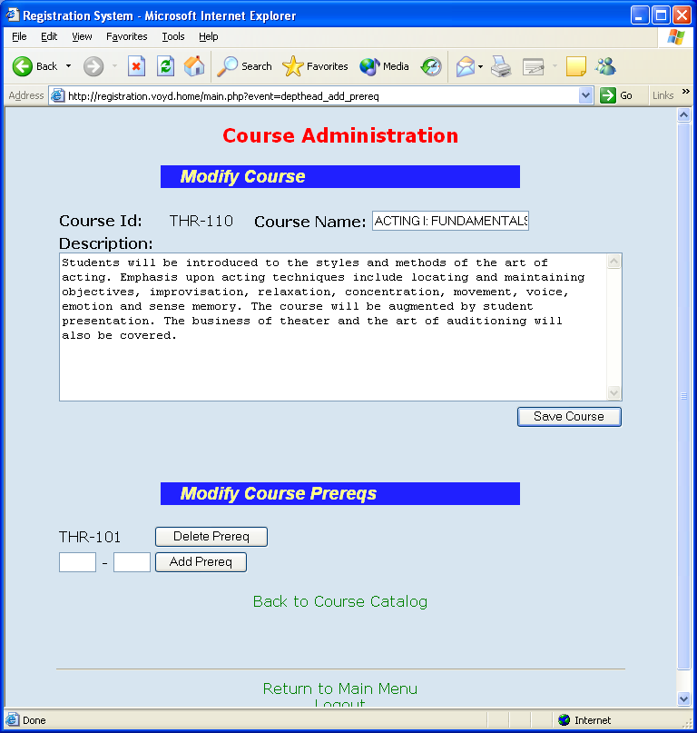

Test Case #6 – Add Prereq that Already Exists

Attempt to re-add prereq THR-101.

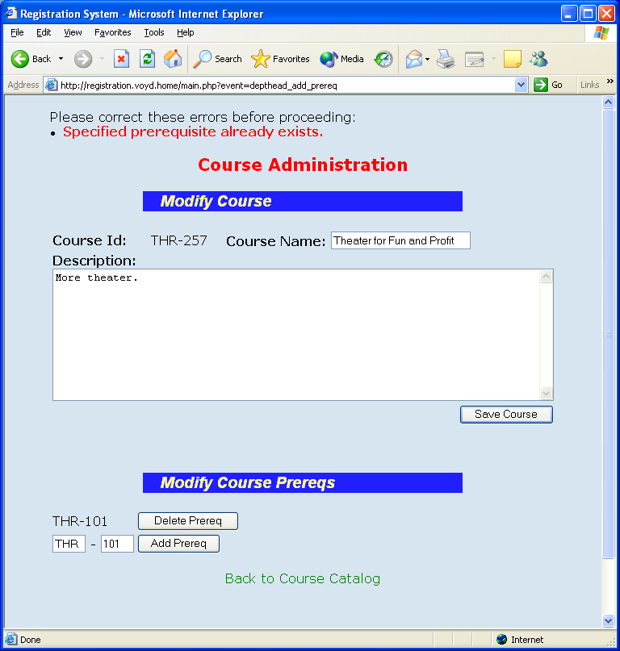

Test Case #7 – Delete Prereq

